**CS648  
Assignment 4**

In this assignment, your job will be to recreate the following 3 layouts using Grid Layout. Recreate the layouts exactly as you see them here (grey boxes, generic text, etc.). The overall width of each design should be 960 pixels wide and each layout should be centered in the browser window. You don’t need to make the heights exactly the same…just do your best to get them as close proportionally as what you’re seeing in these examples. The goal here is to practice with Grid Layout. I added screenshots of these layouts and included them within the ZIP file for this assignment.

**Layout 1**

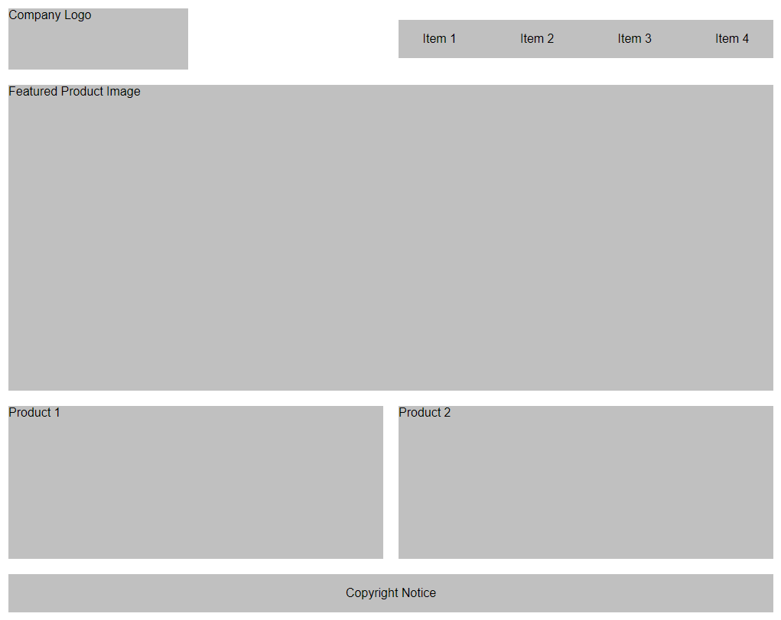

**Layout 2**

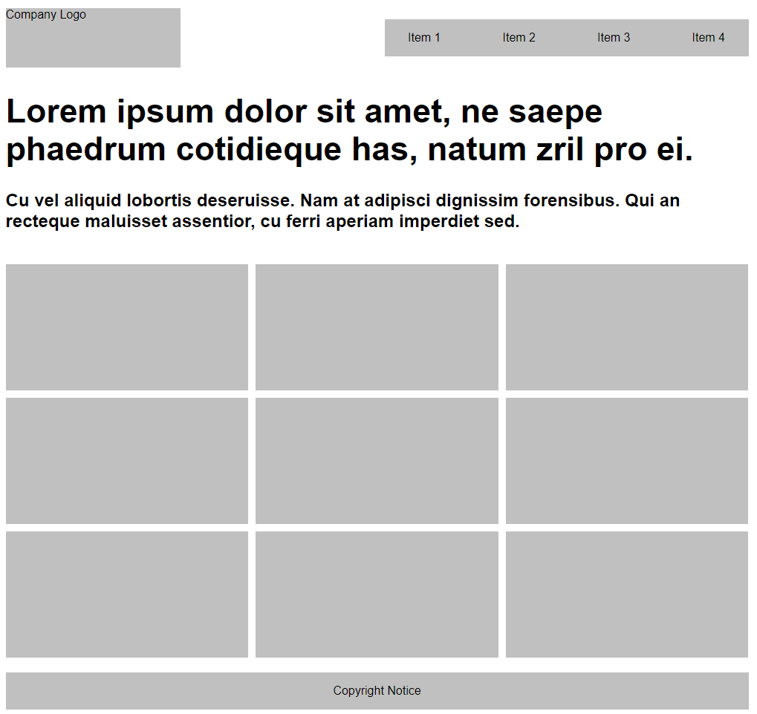

**Layout 3**

